ADD
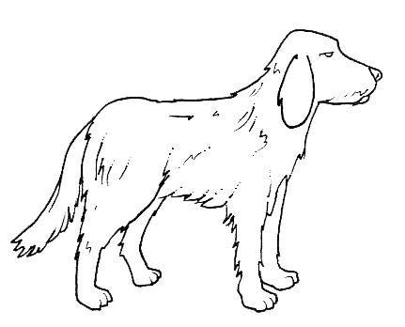
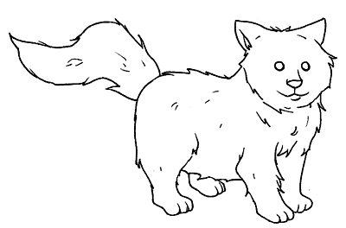

How many dogs? How many cats?

How many pets?

plus equals
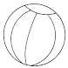


How many balls? How many dolls?

How many toys?

plus equals
SUBTRACT

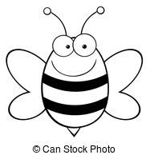

How many bees on the flower?

3 bees fly away. How many bees are still on the flower?

minus equals
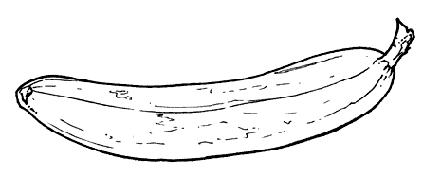

There are 10 bananas. I eat 2 bananas.

How many bananas are left?

minus equals

