Method
1. Heat the oven on its lowest temperature setting. (150 or 180°)2. Make a large aluminum foil pouch and add the tomatoes, onions, garlic, courgettes, bell peppers, eggplant, a pinch of salt and a drizzle of olive oil.
3. Gently toss together and then tightly close the aluminum pouch.
4. Place the pouch in the oven on the lowest setting.
5. Cook, picking up the pouch with tongs and tossing 2 to 3 times while cooking, until everything sounds soft inside, 30/40 minutes approximately .
6. Pour the aluminum pouch contents into a large bowl. Add the lemon zest and a spritz of lemon juice (if you like it) and toss. Taste and season with salt and a few grinds of black pepper (if you like it). Sprinkle over the parsley and serve
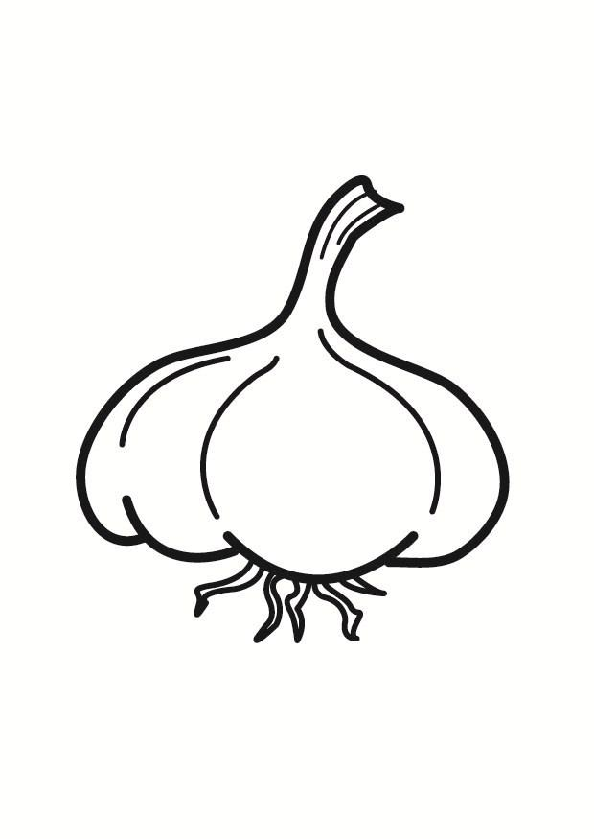
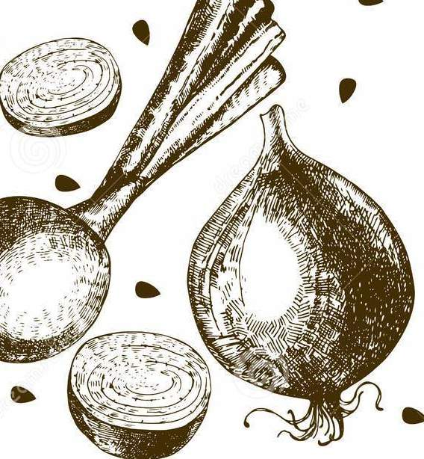
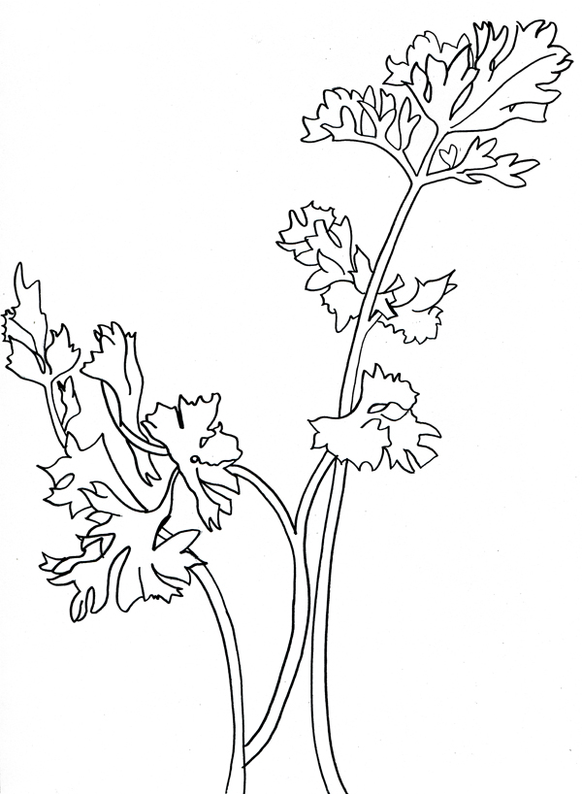
GARLIC

PARSLEY

YELLOW PEPPER

EGGPLANT

COURGETTE

CHERRY TOMATOES

ONIONS

